The University of Technology

Faculty of Engineering & Computing (FENC)

School of Computing & Information Technology (SCIT)

Ethical Hacking- 3005

Assignment 2(CTF)

Tutor: K. Johnson

Mekhi Bentley 2304855

Flag Findings

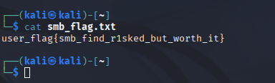
Found In the public shared folder. Command smbclient was used to move this.
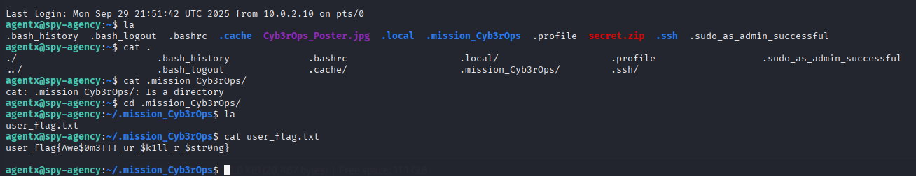
Found in user agentx, in the directory .mission_Cyb3rOps

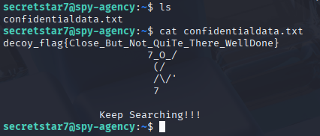
This flag was found after gaining access to user secretstar7.
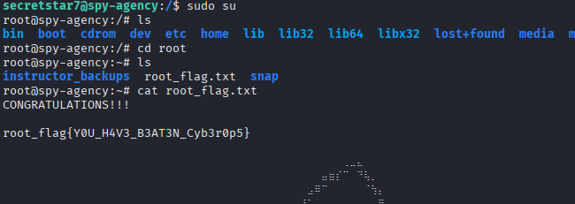

Root flag found in user secretstar7. Enabling root then checking /root.

User Enumeration
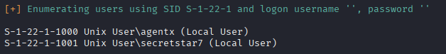
Enumeration of the user on Cyb3rOps machine was conducted by running enum4linux.

NB: Three other ways of Enumeration were attempted. Rpcclient, smbclient and crackmapexec. All where unsuccessful.

Root Flag / Privilege Escalation
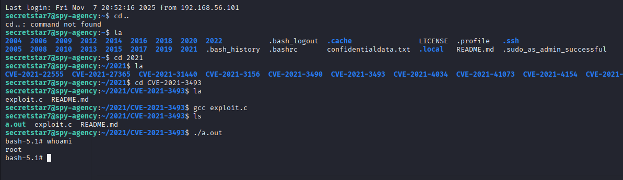
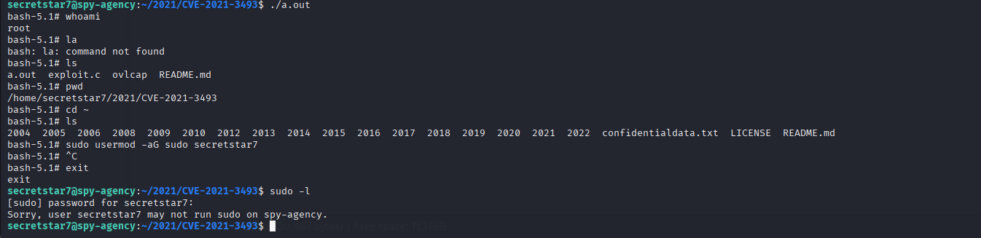

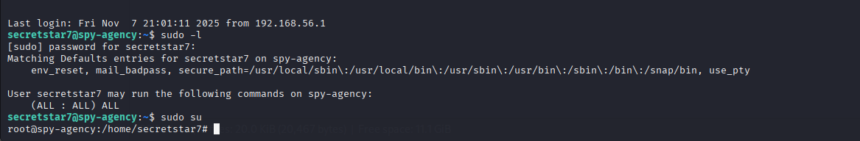
Based on the terminal screenshots, here's the privilege escalation path and root flag I gained initial access to the system as user agentx on the host spy-agency.
Privilege Escalation Vector
The privilege escalation was achieved through sudo misconfiguration. When checking sudo privileges with sudo -l, the system revealed:
User secretstar7 may run the following commands on spy-agency:
(ALL : ALL) ALL
This configuration allows the user secretstar7 to run ANY command as ANY user (including root) without restrictions. This is a critical security misconfiguration.
Exploitation Process
- Discovery: I navigated to /home/secretstar7/2021/CVE-2021-3493/ directory containing an exploit. Which I got from github after doing extensive research
- Compiled and executed an exploit (./a.out) which dropped them into a bash shell with root privileges
- Verified privileges: After running whoami, the output showed root
- Privilege escalation confirmation: I then attempted sudo usermod -aG sudo secretstar7 to add themselves to the sudo group, but this was unnecessary since they already had full sudo access
- Final escalation: Used sudo su to obtain a root shell, which succeeded without password requirement
Root Flag
I successfully escalated to root privileges, as evidenced by the prompt changing from secretstar7@spy-agency to root@spy-agency with the working directory showing root@spy-agency:/home/secretstar7#.
Security Issues Identified
- Unrestricted-partial sudo access - The most critical issue allowing trivial privilege escalation
- No password requirement for sudo commands
- CVE-2021-3493 exploit present - Though the sudo misconfiguration made this unnecessary

Overview
CVE-2021-3493 is a local privilege escalation vulnerability in the Linux kernel's overlayfs file system implementation. It was disclosed in April 2021 and affects Ubuntu kernels (and other distributions using vulnerable kernel versions).
- Attacker creates a user namespace (unprivileged operation)
- Within that namespace, they mount an overlayfs
- They manipulate file attributes/capabilities through the overlay
- The kernel incorrectly preserves elevated capabilities
- Execute a file with unintended root capabilities
- Gain root shell

Web Browser Defaced
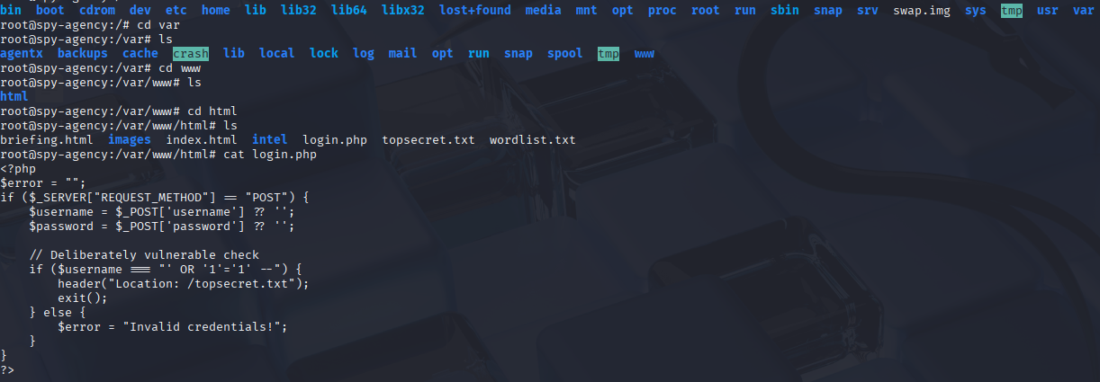

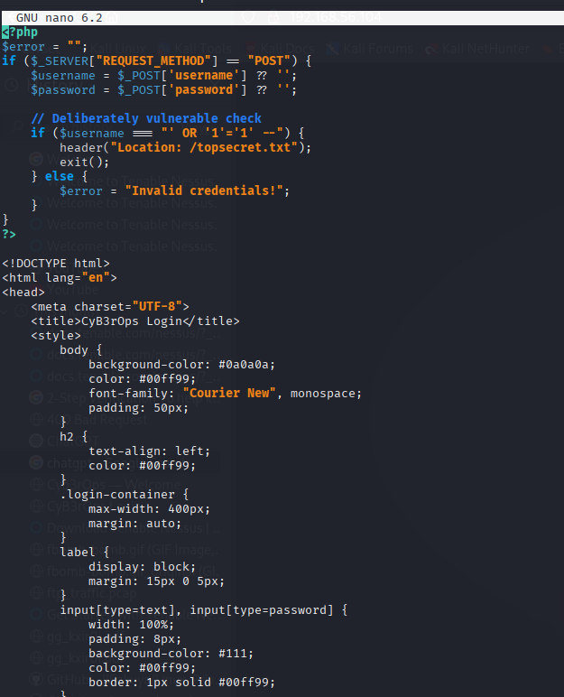

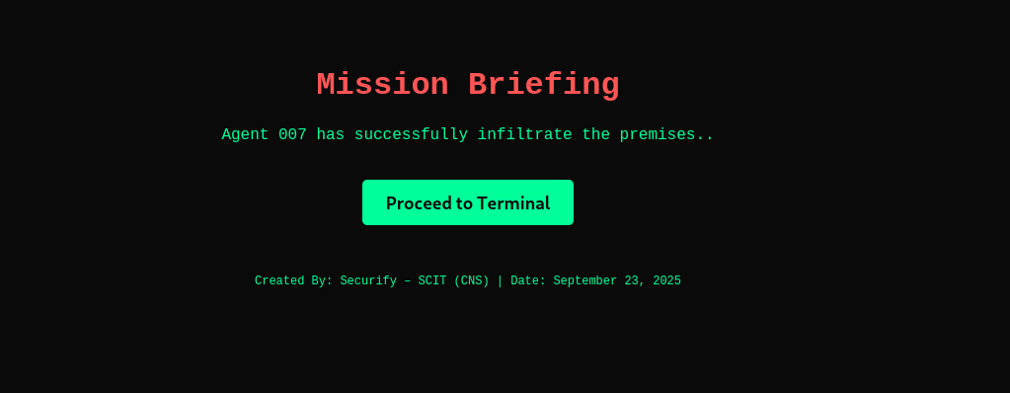
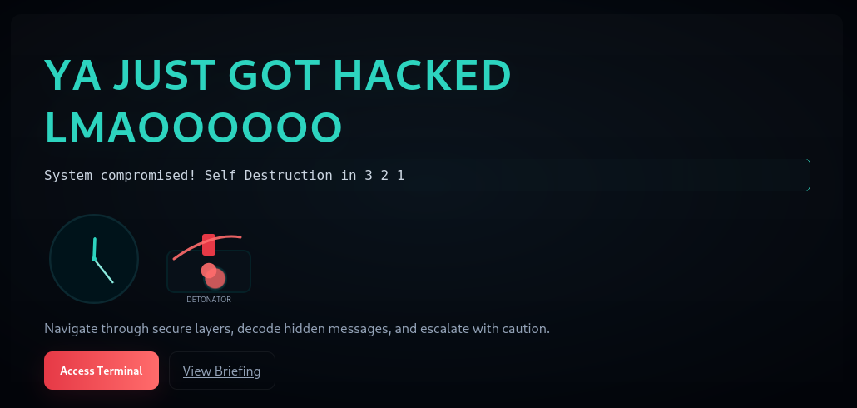

After going through the directories, I moved into the var/www directory where I came across the html files for the webpage. I nano into each html and from there edited to deface the webpage.
Commands run where:
- Cd var/www
- cat login.php, briefing.hmtl idex.html
- nano (each txt file related to the html)

Command Log
